KIARA Advanced Middleware

User Manual

Version 0.1.1

License
KIARA and all the related software are licensed under the terms described in the LGPLv3_LICENSE file included within this distribution.
Table of Contents
1 Introduction 3
1.1 Middleware Operation Modes 3
1.1.1 IDL derived operation mode 3
1.1.2 Application derived operation mode 3
1.1.3 Mapped operation mode 4
2 A quick example 5
2.1 Calculator 5
2.2 Basic procedure 5
2.2.1 IDL derived application process 5
2.2.2 Application derived application example 6
2.2.3 Mapping application example 6
3 Using KIARA Advanced Middleware to create an RPC application 7
3.1 IDL derived operation mode 7
4 Building a KIARA RPC application 8
4.1 Defining a set of remote procedures using the KIARA IDL 8
4.2 Generating remote procedure call support code 9
4.2.1 Installation of the kiaragen tool 10
4.2.2 Generate support code manually using kiaragen 10
4.3 Servant implementation (service functionality) 12
4.4 Implementing the server 12
4.5 Implementing the client 13
4.6 Compiling the client and the server 14

Introduction
KIARA Advanced Middleware is a Java based communication middleware for modern, efficient and secure applications. It is an implementation of the FIWARE Advanced Middleware Generic Enabler.
This first release focuses on the basic features of RPC communication:
- Modern Interface Definition Language (IDL) with a syntax based on the Corba IDL
- Easy to use and extensible Application Programmer Interface (API)
- IDL derived operation mode providing Stubs and Skeletons for RPC Client/Server implementations.
- Synchronous and Asynchronous function calls
Later versions will include additional features like:
- Application derived and Mapped operation mode providing dynamic declaration of functions and data type mapping
- Advanced security features like field encryption and authentication
- Additional communication patterns like publish/subscribe
KIARA Advanced Middleware is essentially a library which is incorporated into the developed applications, the requirements are rather minimal. In particular it requires no service running in the background.

Middleware Operation Modes
The KIARA Advanced Middleware supports multiple operation modes. From traditional IDL-based approaches like Corba, DDS, Thrift up to newer approaches which start with the application data structure and automatically create the wire format. We therefore differentiate three operation modes.

IDL derived operation mode
The IDL derived operation mode is similar to the traditional middleware approaches. Based on the IDL definition we generate with a precompiler stub- and skeleton-classes, which have to be used by the application to implement the server and client (or Publisher/Subscriber) application parts.
- Prerequisite: IDL definition
- Generated: Stubs and Skeletons (at compile time) which have to be used by the application
- Examples: Corba, DDS, Thrift, …

Application derived operation mode
This mode is typical for some modern (e.g. RMI, WebService,...) frameworks. Based on an application specific interface definitions, the framework automatically generates Server- and Client-Proxy-Classes, which serialize the application internal data structures and send them over the wire. Using Annotations, the required serialization and transport mechanisms and type mappings can be influenced. This operation implicitly generates an IDL definition based on the Java interfaces definition and provide this IDL through a “service registry” for remote partners.

- Prerequisite: Application-Interface-Definition (has to be the same on client and server side)
- Generated: Server-/Client-Proxies (generated at runtime)
- Examples: RMI, JAX-RS, Spring REST, …

Mapped operation mode
Goal of the mapped operation mode is to separate the application interfaces from the data structure used to transport the data over the wire. Therefore the middleware has to map the application internal data structure and interfaces to a common IDL definition. Advantage is, that the application interface on client and server (or publisher/subscriber) side can be different.
- Prerequisite: Application-Interface-Definition (can be different on server and client side) IDL Definition
- Generated: Server-/Client-Proxis (generated at runtime, which map the attributes & operations
- Examples: KIARA

Note:
The first release of KIARA will provide support for the traditional IDL derived operation mode. Application derived and mapped operation mode will follow in a future release.

A quick example
In the following chapters we will use the following example application to explain the basic concepts of building an application using KIARA.

Calculator
The KIARA Calculator example application provides an API to ask for simple mathematics operations over two numbers. Is a common used example when trying to understand how an RPC framework works.
Basically the service provides two functions:
- float add (float n1, float n2): Returns the result of adding the two numbers introduced as parameters (n1 and n2).
- float subtract (float n1, float n2): Returns the result of subtracting the two numbers introduced as parameters (n1 and n2).
The KIARA Calculator example is provided within this distribution, so it can be used as starting point.

Basic procedure
Before diving into the details describing the features and configure your project for KIARA, the following quick example should show the basic steps to create a simple client and server application in the different operation modes.
Detailed instructions on how to execute the particular steps are given in chapter Building a KIARA RPC application

IDL derived application process
In the IDL derived approach, first the IDL definition has to be created:

service Calculator
{
float32 add (float32 n1, float32 n2);
float32 subtract (float32 n1, float32 n2);
};

The developer has to implement the functions inside the class CalculatorServantExample:
public static class CalculatorServantImpl extends CalculatorServant
{
@Override
public float add (/*in*/ float n1, /*in*/ float n2) {
return (float) n1 + n2;
}

@Override
public float subtract (/*in*/ float n1, /*in*/ float n2) {
return (float) n1 - n2;
}
...
}

Now the server can be started:
Context context = Kiara.createContext();
Server server = context.createServer();
Service service = context.createService();

// Create and register an instance of the CalculatorServant implementation.
CalculatorServant Calculator_impl = new CalculatorServantImpl();
service.register(Calculator_impl);

// register the service on port 9090 using CDR serialization
server.addService(service, “tcp://0.0.0.0:9090”, ”cdr”);

// run the server
server.run()

The client can connect and call the remote functions via the proxy class:
Context context = Kiara.createContext();

// setup the connection to the server
Connection connection=
context.connect(“tcp://192.168.1.18:9090?serialization=cdr”);

// get the client Proxy implementation
CalculatorClient client = connection.getServiceProxy(CalculatorClient.class);

// call the remote methods
float result = client.add(3, 5);

Application derived application example
This example will be added, when the feature is implemented.

Mapping application example
This example will be added, when the feature is implemented.

Using KIARA Advanced Middleware to create an RPC application
KIARA Advanced Middleware allows the developer to easily implement a distributed application using remote procedure invocations. In client/server paradigm, a server offers a set of remote procedures that the client can remotely call. How the client calls these procedures should be transparent.
For the developer, a proxy object represents the remote server, and this object offers the remote procedures implemented by the server. In the same way, how the server obtains a request from the network and how it sends the reply should also be transparent. The developer just writes the behaviour of the remote procedures.
KIARA Advanced Middleware offers this transparency and facilitates the development.

IDL derived operation mode
The general steps to build an application in IDL derived operation mode are:
- Define a set of remote procedures: using the KIARA Interface Definition Language.
- Generation of specific remote procedure call support code: a Client-Proxy and a Server-Skeleton.
- Implement the servant: with the needed behaviour.
- Implement the server: filling the server skeleton with the behaviour of the procedures.
- Implement the client: using the client proxy to invoke the remote procedures.
This section describes the basic concepts of these four steps that a developer has to follow to implement a distributed application. The advanced concepts are described in section Advanced Concepts.

Building a KIARA RPC application

Defining a set of remote procedures using the KIARA IDL
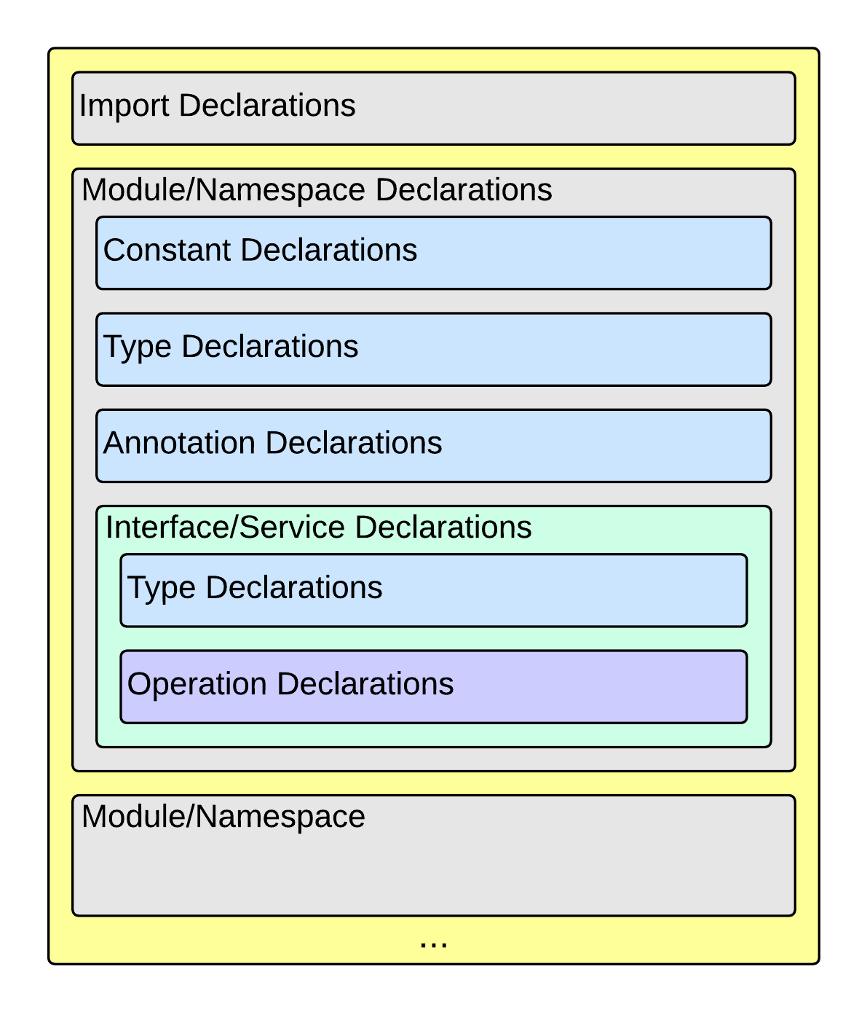
The KIARA Interface Definition Language (IDL) is used to define the remote procedures (operations) the server will offer. Simple and Complex Data Types used as parameter types in these remote procedures are also defined in the IDL file. In addition the KIARA IDL supports the declaration and application of Annotations to add metadata to almost any IDL element. These can be used by the code generator, when implementing the service functionality or configure some specific runtime functionality. The IDL syntax is based on the OMG IDL 3.5. The basic structure of an IDL File is shown in the following picture.
Following a short overview of the supported KIARA IDL elements. For a detailed description please see the chapter “KIARA Interface Definition Language”.
- Import Declarations: Definitions can be split into multiple files and/or share common elements among multiple definitions using the import statement.
- Namespace Declarations: Within a definition file the declarations can be grouped into modules. Modules are used to define scopes for IDL identifiers. KIARA supports the modern keyword namespace. Namespaces can be nested to support multi-level namespaces.
- Constant Declarations: A constant declarations allows the definition of literals, which can be used as values in other definitions (e.g. as return values, default parameters, etc.)
- Type Declarations:
  - Basic Types: KIARA IDL supports the OMG IDL basic data types like float, double, (unsigned) short/int/long, char, wchar, boolean, octet, etc. Additionally it supports modern aliases like float32, float64, i16, ui16, i32, ui32, i64, ui64 and byte
  - Constructed Types: Constructed Types are combinations of other types like. The following constructs are supported:
    - Structures (struct)
  - Template Types: Template types are frequently used data structures like the various forms of collections. The following Template Types are supported:
    - List: Ordered collection of elements of the same type “list” is the modern variant of the OMG IDL keyword “sequence”
    - Strings: collection of chars, will be mapped to the String representation of the language.
- Complex Declarations: In addition to the above Type declarations, KIARA supports multidimensional Arrays using the bracket notation (e.g. int monthlyRevenue[12][10])
- Service Declarations: KIARA supports interface and service declarations via IDL. Meaning that the user can declare different services where the operations are going to be placed.
- Operation Declarations: Operations can be declared within the services following the standard OMG IDL notation.
The IDL file for our example application shows the usage of some of the above elements.
service Calculator
{
float32 add (float32 n1, float32 n2);
float32 substract (float32 n1, float32 n2);
};
calculator.idl

Generating remote procedure call support code
KIARA Advanced Middleware includes a Java application named kiaragen. This application parses the IDL file and generates Java code for the defined set of remote procedures.
All support classes will be generated (e.g. for structs):
- x.y.<StructName>: Support classes containing the definition of the data types as well as the serialization code.
Using the -example option (described below), kiaragen will generate the following files for each of your module/service definitions:
- x.y.<IDL-ServiceName>: Interface exposing the defined synchronous service operation calls.
- x.y.<IDL-ServiceName>Async: Interface exposing the asynchronous operation calls.
- x.y.<IDL-ServiceName>Client: Interface exposing all client side calls (sync & async).
- x.y.<IDL-ServiceName>Proxy: This class encapsulates all the logic needed to call the remote operations. (Client side proxy → stub).
- x.y.<IDL-ServiceName>Servant: This abstract class provides all the mechanisms (transport, un/marshalling, etc.) the server requires to call the server functions.
- x.y.<IDL-ServiceName>ServantExample: This class will be extended to implement the server side functions (see Implementing and Running the Server).
- x.y.ClientExample: This class contains the code needed to run a possible example of the client side application.
- x.y.ServerExample: This class contains the code needed to run a possible example of the server side application.
The package name x.y. can be declared when generating the support code using kiaragen (see -package option below).

Installation of the kiaragen tool
The kiaragen tool is part of the KIARA components available on Maven Central. Depending on your build tool kiaragen can be easily integrated or it can be called with a shell/batch script.
If you are using Maven or an IDE you can download an executable jar file of kiaragen from the KIARA Maven-Central (http://search.maven.org/#search|ga|1|g:org.fiware.kiara) repository, or you can find it in a standalone distribution available online.
On Linux / OS X:
- Download the file kiaragen-x.x.x-capsule.jar from Maven Central
- Rename it to kiaragen-x.x.x.jar and place it in a directory of your shells execute path
(e.g. /usr/local/bin). Alternatively you can also add it to your project dir and call it with a relative path (./scripts/kiaragen.sh).
- To make the execution simpler you can also download the kiaragen.sh script from the kiaragen project (https://github.com/FIWARE-Middleware/kiaragen) and copy it into the scripts directory.
- Now the tool can be called using: kiaragen.sh when the scripts folder in the installation dir is in the execute path or with a relative path ./scripts/kiaragen.sh for project local installations executable flag is lost while downloading, you can set it again using chmod a+x kiaragen
On Windows:
- Download the file kiaragen-x.x.x-capsule.jar from Maven Central
- Rename it to kiaragen-x.x.x.jar and place it in a directory in the windows execute path or place it to your project directory (e.g. subdirectory lib).
- To make the execution simpler you can also download the kiaragen.bat script from the kiaragen project (https://github.com/FIWARE-Middleware/kiaragen) and copy it into the scripts directory.
- Now the tool can be called using: kiaragen.bat when the scripts folder in the installation dir is in the execute path or with a relative path ./scripts/kiaragen.bat for project local installations

Generate support code manually using kiaragen
To call kiaragen manually it has to be installed and in your run path (see above).

The usage syntax is:
$ kiaragen [options] <IDL file> [<IDL file> …]

Options:
Option | Description
-help | Shows help information
-version | Shows the current version of KIARA / kiaragen
-package | Defines the package prefix of the generated java classes. [Default: no package]
-d <path> | Specify the output directory for the generated files.  [Default: current working dir]
-replace | Replaces existing generated files.
-example <platform> | Generates the support files (interfaces, stubs, skeletons,...) for the given target platform. These classes will be used to by the developer to implement both client and server part or the application.  Supported values: gradle (creates also build.gradle files)
--ppDisable | Disables the preprocessor.
--ppPath <path> | Specifies the path of the preprocessor.  [Default: Systems C++ preprocessor]
-t <path> | Specify the output temploral directory for the files generated by the preprocessor.  [Default: machine temp path]

For our example the call could be:
$ kiaragen -example gradle -package com.example src/main/idl/calculator.idl
Loading templates...
org.fiware.kiara.generator.kiaragen
org.fiware.kiara.generator.idl.grammar.Context
Processing the file calculator.idl...
Creating destination source directory... OK
Generating Type support classes...
Generating application main entry files for interface Calculator... OK
Generating specific server side files for interface Calculator... OK
Generating specific client side files for interface Calculator... OK
Generating common server side files... OK
Generating common client side files... OK

This would generate the following files:
.
└── src // source files
├── main
│ ├── idl // IDL definitions for kiaragen
│ │ └── calculator.idl
│ └── java // Generated support files
│ └── com.example
│ │ // Generated using --example
│ ├── Calculator.java // Interface of service
│ ├── CalculatorAsync.java // Interface of async calls
│ ├── CalculatorClient.java // Interface client side
│ ├── CalculatorProxy.java // Client side implementation
│ ├── CalculatorServant.java // Abstract server side skeleton
│ ├── CalculatorServantExample.java // Dummmy servant impl.
│ ├── ClientExample.java // Example client code
│ └── ServerExample.java // Example server code
├── build_client.gradle // generated support files
├── build_server.gradle // generated support files

Servant implementation (service functionality)
Please note that the code inside the file x.y.<IDL-ServiceName>ServantExample.java (which in this case is CalculatorServantExample.java) has to be modified in order to specify the behaviour of each declared function.
class CalculatorServantExample extends CalculatorServant {

public float add (/*in*/ float n1, /*in*/ float n2) {
return (float) n2 + n2;
}

public float substract (/*in*/ float n1, /*in*/ float n2) {
return (float) n1 - n2;
}

}

Implementing the server
The source code generated using kiaragen tool (by using the -example option) contains a simple implementation of a server. This implementation can obviously be extended as far as the user wants, this is just a very simple server capable of executing remote procedures.

The class containing the mentioned code is named ServerExample, and its code is shown below:
public class ServerExample {

public static void main (String [] args) throws Exception {

System.out.println("CalculatorServerExample");

Context context = Kiara.createContext();
Server server = context.createServer();

CalculatorServant Calculator_impl = new CalculatorServantExample();

Service service = context.createService();

service.register(Calculator_impl);

//Add service waiting on TCP with CDR serialization
server.addService(service, "tcp://0.0.0.0:9090", "cdr");

server.run();

}

}

Implementing the client
The source code generated using kiaragen tool (by using the -example option) contains a simple implementation of a client. This implementation must be extended in order to show the output received from the server.
In the KIARA Calculator example, as we have defined first the add function in the IDL file, this will be the one used by default in the generated code. The code for doing this is shown in the following snippet:
public class ClientExample {
public static void main (String [] args) throws Exception {
System.out.println("CalculatorClientExample");

float n1 = (float) 3.0;

float n2 = (float) 5.0;

float ret = (float) 0.0;

Context context = Kiara.createContext();

Connection connection =
context.connect("tcp://127.0.0.1:9090?serialization=cdr");
Calculator client = connection.getServiceProxy(CalculatorClient.class);

try {
ret = client.add(n1, n2);

System.out.println("Result: " + ret);

} catch (Exception ex) {
System.out.println("Exception: " + ex.getMessage());
return;
}
}
}

The previous code has been shown exactly the way it is generated, with only two differences:
- Parameter initialization: Both of the parameters n1 and n2 have been initialized to random values (in this case 3 and 5).
- Result printing: To have feedback of the response sent by the server when the remote procedure is executed.

Compiling the client and the server
For the client and server examples to compile, some jar files are needed. These files are located under the lib directory provided with this distribution, and they must be placed in the root working directory, under the lib folder.
.
└── src // source files
├── lib // generated support files
├── build_client.gradle // generated support files
├── build_server.gradle

To compile the client using gradle, the call would be the next (changing the file build_client.gradle to build_server.gradle will compile the server):
$ gradle -b build_client.gradle build
:compileJava
:processResources UP-TO-DATE
:classes
:jar
:assemble
:compileTestJava UP-TO-DATE
:processTestResources UP-TO-DATE
:testClasses UP-TO-DATE
:test UP-TO-DATE
:check UP-TO-DATE
:build

BUILD SUCCESSFUL

Total time: 3.426 secs

After compiling both of them the following files will be generated:
.
└── src // source files
├── build // generated by gradle
│ ├── classes // Compiled .class files
│ ├── dependency-cache // Inner gradle files
│ ├── libs // Executable jar files
│ └── tmp // Temporal files used by gradle
├── lib
├── build_client.gradle // generated support files
├── build_server.gradle // Generated support files

In order to execute the examples, copy them to the same locations where the libraries mentioned before are placed (lib directory), and execute them using the command java -jar file_to_execute.jar
All the files needed to compile and execute this project are located under the examples/Calculator directory included with this distribution.

